Stations of the Cross – Pope Francis

Introduction

Priest: In the name of the Father and of the Son and of the Holy Spirit. Amen

Priest: Blessed be the Holy and Undivided Trinity
All: Both now and forever. Amen

Dear Brothers and Sisters, the word of the Cross is also the answer which Christians offer in the face of evil, the evil that continues to work in us and around us. Christians must respond to evil with good, taking the Cross upon themselves as Jesus did.

Let us all have the courage, yes, courage, to walk in the presence of the Lord, with the Lord’s Cross; to build the Church on the Lord’s blood which was poured out on the Cross; and to profess the one glory: Christ crucified. And in this way, the Church will go forward.

So let us walk the Way of the Cross, guided by the Spirit, praying that we might grow in grace and have the courage to profess Jesus Christ as Lord. Amen

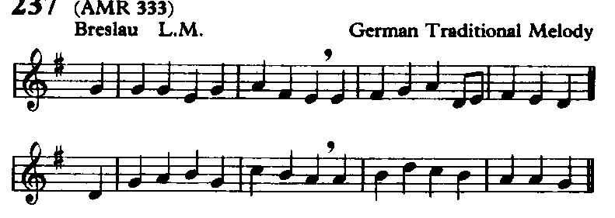
Please move to the First Station as we sing:

Take up thy cross, the Saviour said,
if thou wouldst my disciple be:
deny thyself, the world forsake,
and humbly follow after me.

Take up thy cross: let not its weight
fill thy weak spirit with alarm;
his strength shall bear thy spirit up,
and brace thy heart, and nerve thine arm.

1 Jesus is condemned to death

Priest: We adore you, O Christ, and we bless you
All: For by your cross, you have redeemed and saved us.

Reader 1 Pilate asked him, “So you are a king?” Jesus answered, “You say that I am a king. For this I was born , and for this I came into the world, to testify to the truth. Everyone who belongs to the truth listens to my voice.” Pilate asked him, “What is truth?” (Jn 18. 37-38)

Reader 2 The question arises: does “the” truth really exist? What is “the” truth? Can we know it? Here springs to my mind the question of Pontius Pilate, the Roman Procurator, when Jesus reveals to him the deep meaning of his mission: “What is truth?” Pilate cannot understand that “the” Truth is standing in front of him, he cannot see in Jesus the face of the truth that is the face of God. And yet Jesus is exactly this: the Truth that, in the fullness of time, “became flesh” and came to dwell among us so that we might know it. The truth is not grasped as a thing, the truth is encountered. It is not a possession; it is an encounter with the Person.

Reader 3 Lord Jesus, open our ears to your word,
our eyes to your way and
our hearts to your Truth;
today and every day. Amen

As we walk to the next station, we sing:
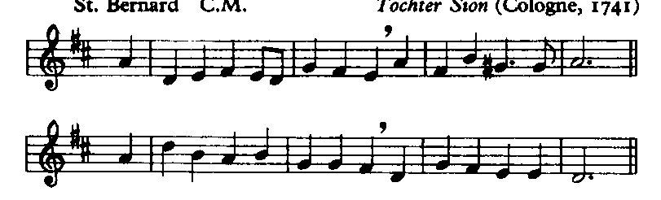

All ye who seek for sure relief
in trouble and distress,
whatever sorrow vex the mind,
or guilt the soul oppress;

2 Jesus Takes Up His Cross

Priest: We adore you, O Christ, and we bless you
All: For by your cross, you have redeemed and saved us.

Reader 1 Now it was the Day of Preparation for the Passover; and it was about noon. He said to the Jews, “Here is your king!” They cried out, “Away with him; away with him! Crucify him!” Pilate asked them, “Shall I crucify your king?” The chief priests answered, “We have no king but the emperor.” Then he handed him over to them to be crucified. So they took Jesus; and carrying the cross by himself, he went out to what is called the The Place of the Skull, which in Hebrew is called Golgotha. (Jn 19. 14-17)

Reader 2 The cross is the word through which God has responded to evil in the world. Sometimes it may seem as though God does not react to evil, as if he is silent. And yet, God has spoken, he has replied, and his answer is the Cross of Christ: a word which is love, mercy, forgiveness, It also reveals a judgement, namely that God, in judging us, loves us. Let us remember this: God judges us by loving us. If I embrace his love then I am saved; if I refuse it, then I am condemned, not by him, but by my own self, because God never condemns, he only loves and saves.

Dear brothers and sisters, the word of the Cross is also the answer which Christians offer in the face of evil, the evil that continues to work in us and around us, Christians must respond to evil with good, taking the Cross upon themselves as Jesus did.

Reader 3 Lord Jesus, the source of love, mercy and forgiveness,
forgive us when we fail you,
have mercy upon us when we do wrong
and fill us with your love to try again. Amen

As we walk to the next station, we sing:

Jesus, who gave himself for you
upon the cross to die,
opens to you his sacred heart:
O to that heart draw nigh.

3 Jesus Falls for the First Time

Priest: We adore you, O Christ, and we bless you
All: For by your cross, you have redeemed and saved us.

Reader 1 Surely he has borne our infirmities and carried our diseases; yet we accounted him stricken, struck down by God, and afflicted. But he was wounded for our transgressions, crushed for our iniquities; upon him was the punishment that made us whole, and by his bruises we are healed. All we like sheep have gone astray; we have all turned to our own way, and the Lord has laid on him the iniquity of us all. (Is 53. 4-6)

Reader 2 Following Jesus does not mean participating in a triumphal procession! It means sharing his merciful love, entering into his great work of mercy for each person and for all mankind. And this forgiveness passes through the Cross. Jesus insists on the conditions to be his disciple: to not place anything before love of him, to take up one’s own cross, and to follow him. Although there are many who want to follow Jesus, especially when there are miracles, Jesus does not want to deceive anyone. Jesus knows well what awaits him in Jerusalem, what the way is that that the Father asks him to walk. It is the Way of the Cross, of sacrifice of himself for the forgiveness of our sins. Yet Jesus does not want to complete this work alone. Christ wants to include us also in the mission that the Father has given him.

Reader 3 Lord Jesus, you have called us to your service;
help us to love you above all things,
to take up our cross daily
and to follow you faithfully. Amen

As we walk to the next station, we sing:

Ye hear how kindly he invites;
ye hear his words so blest:
‘All ye that labour come to me,
and I will give you rest.’

4 Jesus Meets His Mother

Priest: We adore you, O Christ, and we bless you
All: For by your cross, you have redeemed and saved us.

Reader 1 Then Simeon blessed them and said to his mother Mary, “This child is destined for the falling and rising of many in Israel, and to be a sign that will be opposed so that the inner thoughts of many will be revealed – and a sword will pierce your own soul too.” His mother treasured all these things in her heart. (Lk 2. 34-35, 51)

Reader 2 In order to enter into this mystery, which is not a labyrinth but resembles one a little bit, we need the Mother, the Mother’s hand. That she, Mary, will make us understand how great and humble this mystery is; how sweet as honey and how bitter as aloe. That she will be the one who accompanies us on this journey, which no one can take if not ourselves. Each one of us must take it! With the mother, weeping and on our knees.

Reader 3 Lord Jesus, hold us in your loving embrace
and walk with us day by day;
that we might reveal your love
to our needy world. Amen

As we walk to the next station, we sing:

O Jesus, joy of saints on high,
thou hope of sinners here,
attracted by those loving words
to thee we lift our prayer.

5 Simon helps Jesus carry his Cross

Priest: We adore you, O Christ, and we bless you
All: For by your cross, you have redeemed and saved us.

Christ speaks My strength is gone; I can no longer bear the cross alone. And so the legionnaires make Simon give me aid. This Simon is like you, my other self.

Give me your strength. Each time you lift some burden from another’s back, you lift as with your very hand the cross’ awful weight that crushes me.

I reply Lord, make me realize that every time I wipe a dish, pick up an object off the floor, assist a child in some small task, or give another preference in traffic or the store; each time I feed the hungry, clothe the naked, teach the ignorant, or lend my hand in any way – it matters not to whom – my name is Simon. And the kindness I extend to them I really give to you.

As we walk to the next station, we sing:

Wash thou our wounds in that dear blood
which from thy heart doth flow;
a new and contrite heart on all
who cry to thee bestow.

6 Veronica wipes the face of Jesus

Priest: We adore you, O Christ, and we bless you
All: For by your cross, you have redeemed and saved us.

Christ speaks Can you be brave enough, my other self, to wipe my bloody face? Where is my face, you ask?

At home whenever eyes fill up with tears, at work when tensions rise, on playgrounds, in the slums, the courts, the hospitals, the jails – wherever suffering exists – my face is there. And there I look for you to wipe away by blood and tears.

I reply Lord, what you ask is hard. It calls for courage and self sacrifice, and I am weak. Please give me strength. Don’t let me run away because of fear.

Lord, live in me and act in me and love in me. And not in me alone – in all of us – so that we may reveal no more your bloody but your glorious face on earth.

As we walk to the next station, we sing:

O Dearest Lord, thy sacred head
with thorns was pierced for me;
O pour thy blessing on my head
that I may think for thee.

7 Jesus Falls for the Second Time

Priest: We adore you, O Christ, and we bless you
All: For by your cross, you have redeemed and saved us.

Christ speaks This seventh step, my other self, is one that tests your will. From this fall learn to persevere in doing good.

The time will come when all your efforts seem to fail and you will think, “I can’t go on.”

Then turn to me my heavy-laden one, and I will give you rest. Trust me and carry on.

I reply Give me your courage, Lord. When failure presses heavily on me and I am desolate, stretch out your hand to lift me up.

I know I must not cease, but persevere in doing good.

But help me, Lord, Alone there’s nothing I can do. With you, I can do anything you ask. I will.

As we walk to the next station, we sing:

O Dearest Lord, thy sacred hands
with nails were pierced for me;
O shed thy blessing on my hands
that they may work for thee.

8 Jesus meets the Women of Jerusalem

Priest: We adore you, O Christ, and we bless you
All: For by your cross, you have redeemed and saved us.

Christ speaks How often had I longed to take the children of Jerusalem and gather them to me. But they refused. And now these women weep for me and my heart mourns for them – mourns for their sorrows that will come.

I comfort those who seek to solace me.

How gentle can you be, my other self? How kind?

I reply My Jesus, your compassion in your passion is beyond compare.

Lord, teach me, help me learn. When I would snap at those who hurt me with their ridicule, those who misunderstand, or hinder me with some misguided helpfulness, those who intrude upon my privacy – then help me curb my tongue. May gentleness become my cloak. Lord, make me kind like you.

As we walk to the next station, we sing:

O Dearest Lord, thy sacred feet
with nails were pierced for me;
O pour thy blessing on my feet
that they may follow thee.

9 Jesus falls for the Third Time

Priest: We adore you, O Christ, and we bless you
All: For by your cross, you have redeemed and saved us.

Christ speaks Completely drained of strength I lie, collapsed, upon the cobblestones. My body cannot move. No blows, no kicks, can rouse it up. And yet my will is mine. And so is yours.

Know this, my other self, your body may be broken, but no force on earth and none in hell can take away your will. Your will is yours.

I reply My Lord, I see you take a moment’s rest then rise and stagger on. And I can do the same because my will is mine. When all my strength is gone and guilt and self-reproach press me to earth and seem to hold me fast, protect me from the sin of Judas – save me from despair!
Lord, never let me feel that any sin of mine is greater than your love. No matter what my past has been I can begin anew.

As we walk to the next station, we sing:

O Dearest Lord, thy sacred heart
with spear was pierced for me;
O pour thy Spirit in my heart
that I may live for thee.

10 Jesus Is Stripped

Priest: We adore you, O Christ, and we bless you
All: For by your cross, you have redeemed and saved us.

Christ speaks Behold my other self, the poorest king who ever lived. Before my creatures I stand stripped. The cross – my deathbed – even this is not my own. Yet who has ever been so rich? Possessing nothing, I own all – my Father’s love.

If you, too, would own everything, be not solicitous about your food, your clothes or even your life.

I reply My Lord, I offer you my all – whatever I possess, and more, my self.

Detach me from the craving for prestige, position, wealth. Root out of me all trace of envy of my neighbour who has more than I. Release me from the vice of pride, my longing to exalt myself, and lead me to the lowest place. May I be poor in spirit, Lord, so that I can be rich in you.

As we walk to the next station, we sing:

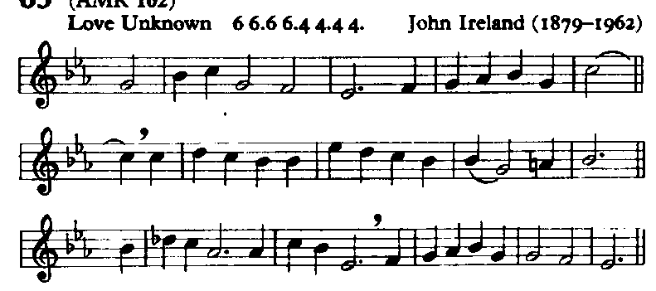

My song is love unknown,
my Saviour’s love to me,
love to the loveless shown,
that they might lovely be.
O who am I, that for my sake
my Lord should take frail flesh, and die?

11 Jesus is nailed to the Cross

Priest: We adore you, O Christ, and we bless you
All: For by your cross, you have redeemed and saved us.

Christ speaks Can you imagine what a crucifixion is? My executioners stretch my arms; they hold my hand and wrist against the wood and press the nail until it stabs my flesh. Then, with one heavy hammer smash, they drive it through – and pain bursts like a bomb of fire in my brain. They seize the other arm; and agony again explodes. Then raising up my knees so that my feet are flat against the wood, they hammer them fast, too.

I reply My God, I look at you and think: “Is my soul worth this much?” What can I give you in return? I here and now accept for all my life whatever sickness, torment, agony may come. To every cross I touch my lips.

O blessed cross that lets me be – with you – a co-redeemer of humanity.

As we walk to the next station, we sing:

He came from his blest throne,
salvation to bestow;
but men made strange, and none
the longed-for Christ would know.
But O, my Friend, my Friend indeed,
who at my need his life did spend!

12 Jesus speaks to his mother

Priest: We adore you, O Christ, and we bless you
All: For by your cross, you have redeemed and saved us.

Christ speaks They said they would stay with me, whatever happened. And now, my other self, it has happened - where are they? But you, Mary, Mother, have remained faithful. And your pain is almost as great as mine. From the pain of childbirth to the pain of death, you have never left me.

I cannot go on alone – you know that with a mother’s intuition, and that is why you are here.

I speak Lord, when I am tempted to think that I don’t need anyone else, remind me of your cross. When I am tempted to ignore another’s pain and sorrow, remind me of Mary’s faithfulness. When I find myself alone, or weighed down by anxiety or pain, may I come to the foot of your cross and offer myself to you?

Increase in me sensitivity, and never let me fall into the sin of ignoring the needs of others, lest I also forget your suffering for my sake.

As we walk to the next station, we sing:

Sometimes they strew his way,
and his sweet praises sing;
resounding all the day
hosannas to their King.
Then ‘Crucify!’ is all their breath,
and for his death they thirst and cry.

13 Jesus Dies on the Cross

Priest: We adore you, O Christ, and we bless you
All: For by your cross, you have redeemed and saved us.

Christ speaks The cross becomes a pulpit now – “Forgive them, Father….You will be with me in Paradise….There is your mother….There…your son….I thirst….It is complete.”
To speak I have to raise myself by pressing on my wrists and feet, and every move engulfs me in new waves of agony. And then, when I have borne enough, have emptied my humanity, I let my mortal life depart.

I reply My Jesus, God, what can I say or do?

I offer you my death with all its pains, accepting now the time and kind of death in store for me. Not by a single instant would I lengthen my life’s span. I offer you my death for my own sins and for those of all humanity. My God! My God! Forsake us not. We know not what we do.

As we walk to the next station, we sing:

Why what hath my Lord done?
What makes this rage and spite?
He made the lame to run,
he gave the blind their sight.
Sweet injuries! yet they at these
themselves displease, and ‘gainst him rise.

14 Jesus Is Taken Down from the Cross

Priest: We adore you, O Christ, and we bless you
All: For by your cross, you have redeemed and saved us.

Christ speaks The sacrifice is done. Yes, my Offering is complete; but not my mother’s – and not yours, my other self. My mother still must cradle in her arms the lifeless body of the son she bore. You, too, must part from those you love, and grief will come to you.

In your bereavements think of this: A multitude of souls were saved by Mary’s sharing in my Calvary. Your grief can also be the price of souls.

I reply I beg you, Lord, help me accept the partings that must come – from friends who go away, my children leaving home, and most of all, my dear ones when you shall call them to yourself.

Then, give me grace to say: “As it has pleased you, Lord, to take them home, I bow to your most holy will. And if by just one word I might restore their lives against your will, I would not speak.”

Grant them eternal joy.

As we walk to the next station, we sing:

They rise, and needs will have
my dear Lord made away;
a murderer they save,
the Prince of Life they slay.
Yet cheerful he to suffering goes,
that he his foes from thence might free.

15 Jesus Is Laid in the tomb

Priest: We adore you, O Christ, and we bless you
All: For by your cross, you have redeemed and saved us.

Christ speaks So ends my mortal life.

But now another life begins for Mary, and for Magdalen, for Peter and for John and you. My life’s work is done. My work within and through my church must now commence. I look to you, my other self. Day in, day out, from this time forth, be my apostle – victim – saint.

I reply My Jesus, Lord, You know my spirit is as willing as my flesh is weak.

The teaching you could not impart, the sufferings you could not bear, the works of love you could not do in your short life on earth, let me impart, and bear, and do through you. But I am nothing, Lord. Help me!

As we return to our pews in the Lady Chapel, we sing:

In life, no house, no home
my Lord on earth might have;
in death, no friendly tomb
but what a stranger gave.
What may I say? Heaven was his home;
but mine the tomb wherein he lay.

Here might I stay and sing:
no story so divine;
never was love, dear King,
never was grief like thine!
This is my Friend, in whose sweet praise
I all my days could gladly spend.

Conclusion

Christ speaks I told you at the start, my other self, my life was not complete until I crowned it by my death. Your “way” is not complete unless you crown it by your life.

Accept each moment as it comes to you, with faith and trust that all that happens has my mark on it. A simple fiat, this is all it takes; a breathing in your heart, “I will it, Lord.”

So seek me not in far-off places. I am close at hand. Your workbench, office, kitchen, these are altars where you offer love. And I am with you there.

Go now! Take up your cross and with your life complete your way.

We remain kneeling for the final hymn

Take up thy cross, the Saviour said,
if thou wouldst my disciple be:
deny thyself, the world forsake,
and humbly follow after me.

Take up thy cross, and follow Christ,
nor think till death to lay it down;
for only they who bear the cross
may hope to wear the glorious crown.

Priest: Christ give you grace to grow in holiness, to deny yourselves, take up your cross, and follow him; and the blessing of God almighty, the Father, the Son and the Holy Spirit be among you and remain with you always. Amen

-------------------

